Camp Lejeune water survivors urged to file claim before deadline
By Riley Ceder
Thursday, Aug 8, 2024
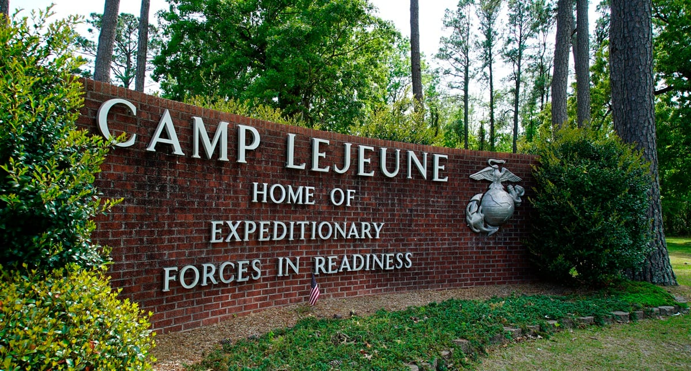Were you impacted by contaminated water at Marine Corps Base Camp Lejeune between 1953 and 1987? Time is running out to file a claim. (AP Photo/Allen G. Breed, File)
The Navy is advising veterans exposed to contaminated water aboard Marine Corps Base Camp Lejeune, North Carolina, to file their claim by the August 10 deadline.
Veterans can go to https://clclaims.jag.navy.mil to get the claims process started.
This comes two years after President Biden signed into law the Honoring our Promise to Address Comprehensive Toxics (PACT) Act. The legislation included the Camp Lejeune Justice Act, which allows those affected by toxic materials at the camp to sue the federal government for compensation.
The PACT Act also provides toxic exposure screenings and follow-up screenings to veterans enrolled in Department of Veterans Affairs health care.
Service members affected by toxic water at Camp Lejeune between Aug. 1, 1953, and Dec. 31, 1987, are eligible to file a claim.

RELATED
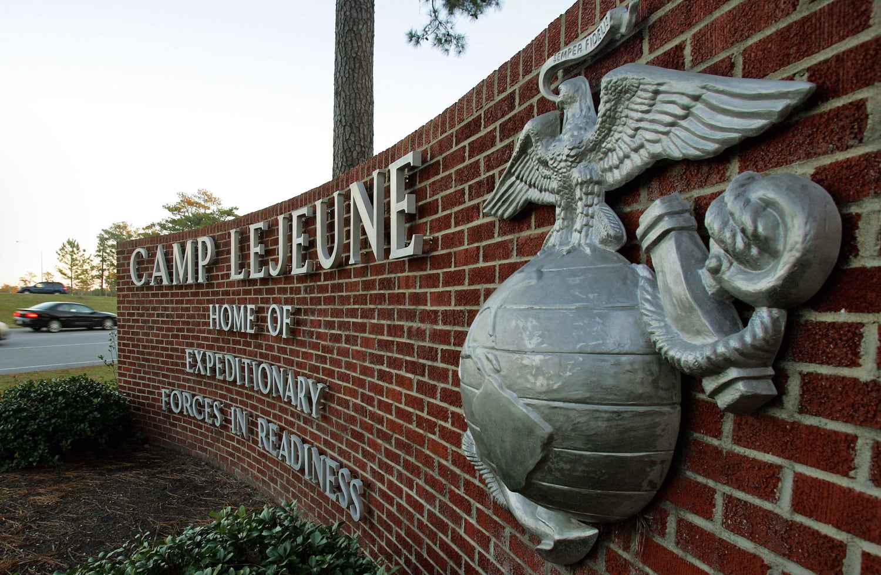

Camp Lejeune water contamination tied to several cancers, study shows

Military personnel stationed at Camp Lejeune from 1975–1985 had at least a 20% higher risk for a number of cancers than those stationed elsewhere.
Veterans and family members who were exposed to contaminated water at Camp Lejeune are 70% more likely to develop Parkinson’s disease than other service members, according to a study published in the Journal of the American Medical Association.
Chemicals from an off-site dry cleaning firm leaked into the base’s water supply beginning in the 1950s, but the military didn’t discover the contamination until 1982.
The Associated Press has also reported that the water at Camp Lejeune accounted for a 20% increase in cancer risk for service members stationed there from 1975 to 1985.

